CIS020-2 – Systems Development and Modern Database Practices

Assignment 2 – Student Information Kiosk (SIK) Case Study - Group Assignment

Group Number – Group 12

1814927 – Michael Songer

1802745- Zaid Rasool

Contents

Team member roles 2

Introduction 2

Plan of work 2

Role identification 2

Users 2

Client/stakeholder 3

Service/audience 3

Soft Systems Methodology (SSM) 3

Rich Picture 3

Root Definition 3

CATWOE 3

Conceptual Data Model 3

The three E’s 3

Requirements 4

Use case diagram 4

Activity diagram 7

Class diagram 9

Entity relationship diagram 10

Skeleton Tables 10

Entity Relationships 11

In Entity relationship diagrams there are relations between student, booking, admin and event. 11

Normalisation 11

Data Dictionary 12

Database Design 14

Tables 14

SQL 15

User-interface design 16

Security 17

Implementation of kiosk 17

Innovations 17

Test system 17

Future evolutions 17

Conclusion 17

References 18

Appendix 18

# Team member roles

1814927 - Michael songer

Team manager, group report, introduction, plan of work, role identification, soft system methodology, requirements, database design, user-interface design, security, implementations of kiosk, innovations, test system, future evolutions.

1802745-Zaid Rasool

Use case diagram, activity diagram, Class diagram, Entity relationship, Normalisation, Data dictionary, Skelton tables, Entity relationship diagrams, Rich picture, Conclusion

# Introduction

The goal of the assignment is to design and make a student information kiosk that will be a useful tool for university students. It should have a variety of tools that informs students about different what’s happening both in the university and locally.

# Plan of work

The group originally started as six people but ended up going down to two, making doing the work very difficult. So, we tried to split the work evenly. Michael was set as group leader, but assigning the work was agreed together. Michael was to come up with the requirements and design the soft system methodologies. From the requirements Zaid was to do the UML diagrams. Michael then was to work on the database design and GUI design. Once all the designing was done and agreed upon it will be implemented into oracle apex.

# Role identification

## Users

Students, university staff and admin. The university staff and admin will be the ones who add things like event details and local points of interest.

## Client/stakeholder

University dean, university students, university staff, university event management team, university administration.

## Service/audience

The service is an online kiosk that is designed to provide information to students of the university of Bedfordshire. The information will be things like local places of interest, events (both on campus and near). It will also inform the students of where they can get support if they require it.

# Soft Systems Methodology (SSM)

## Rich Picture

Student information kiosk the rich picture is used to define a situation and show in different diagrams. A rich picture shares different situations. In a rich picture, they are described in two steps.

* In Student, information kiosk identifies the issue that wishes to address
* Develop an unstructured description of a situation where issues lie

A rich picture participate in the discussion and share the good situation

. (Stevens, 2016)

## Root Definition

The student information kiosk is made to easily show students anything that will be of interest to them (x), by means of a simple/easy to use online system(y), in order to aid them in getting a memorable university experience and meet other students with similar interest.

## CATWOE

C – Students

A – University staff

T – Increase popularity/knowledge of things students may be interested in.

W – Having students socialise together more will help their social skills for the future and having students at local events will increase people’s views on the university.

O – University dean and university event management team.

E – University budget, internet/mobile data connectivity, student devices, interest.

## Conceptual Data Model

## The three E’s

Efficacy -

Efficiency -

Effectiveness -

# Requirements

We were able to get an initial list of requirements from the clients brief.

|  |  |  |  |  |
| --- | --- | --- | --- | --- |
| Functional requirements | | | | |
| ID | Requirement | Priority | Owner | Source |
| 1.0 | Track campus events | High | Michael | Client brief |
| 1.0.1 | Bookmark campus events | Medium | Michael | Client brief |
| 1.1 | Track local events | High | Michael | Client brief |
| 1.1.1 | Bookmark local events | Medium | Michael | Client brief |
| 1.2 | Track points of interest | High | Michael | Client brief |
| 1.2.1 | Bookmark points of interest | Medium | Michael | Client brief |
| 1.3 | Track local support for students | High | Michael | Client brief |
| 1.3.1 | Bookmark local support for students | Medium | Michael | Client brief |

|  |  |  |  |  |
| --- | --- | --- | --- | --- |
| Non-functional requirements | | | | |
| ID | Requirement | Priority | Owner | Source |
| 2. | Accessibility options | High | Michael | Client brief |
| 3. | Efficient data usage | High | Michael | Client brief |
| 4. | Simple to use | High | Michael | Client brief |
| 5. | Minimum device storage | Medium | Michael | Client brief |

# Use case diagram

The Use case diagram between student and database are following:

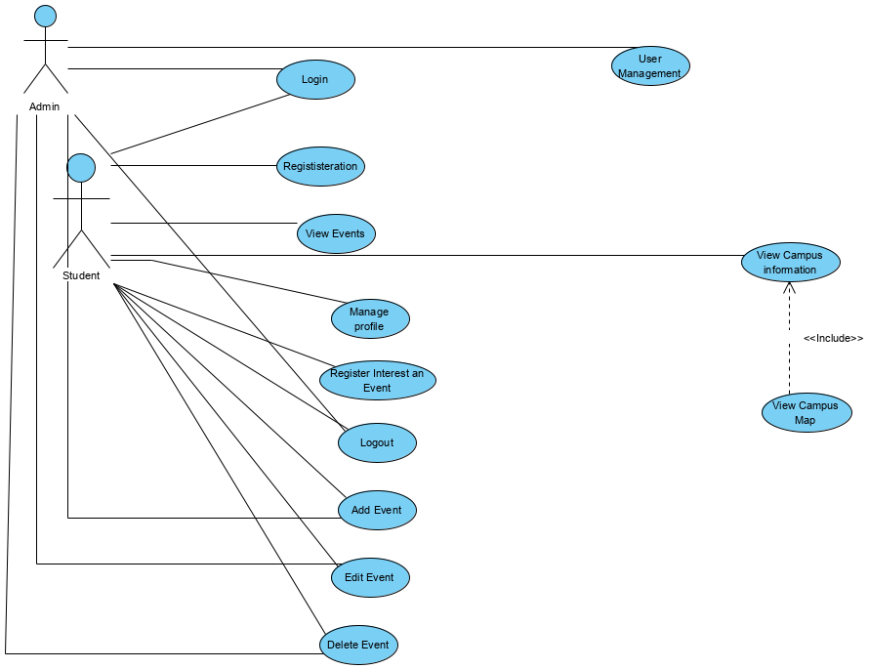

# Activity diagram

The activity diagram are following:

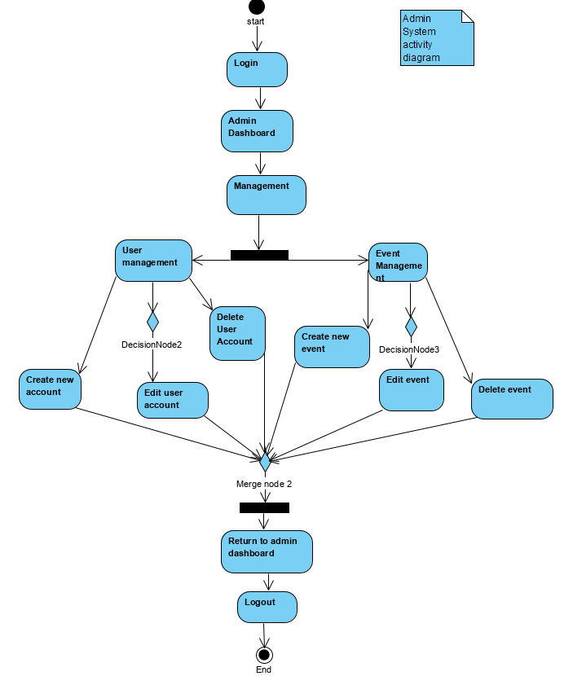

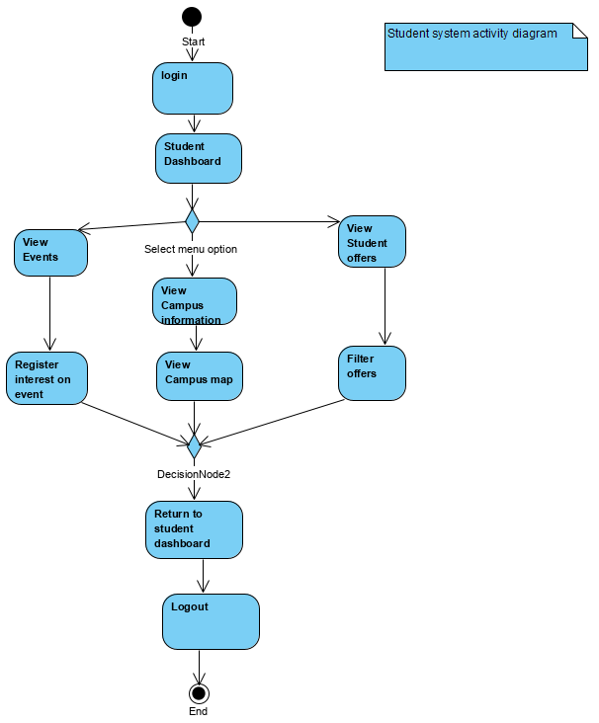

# Class diagram

The class diagram between student, booking, admin and event are following:

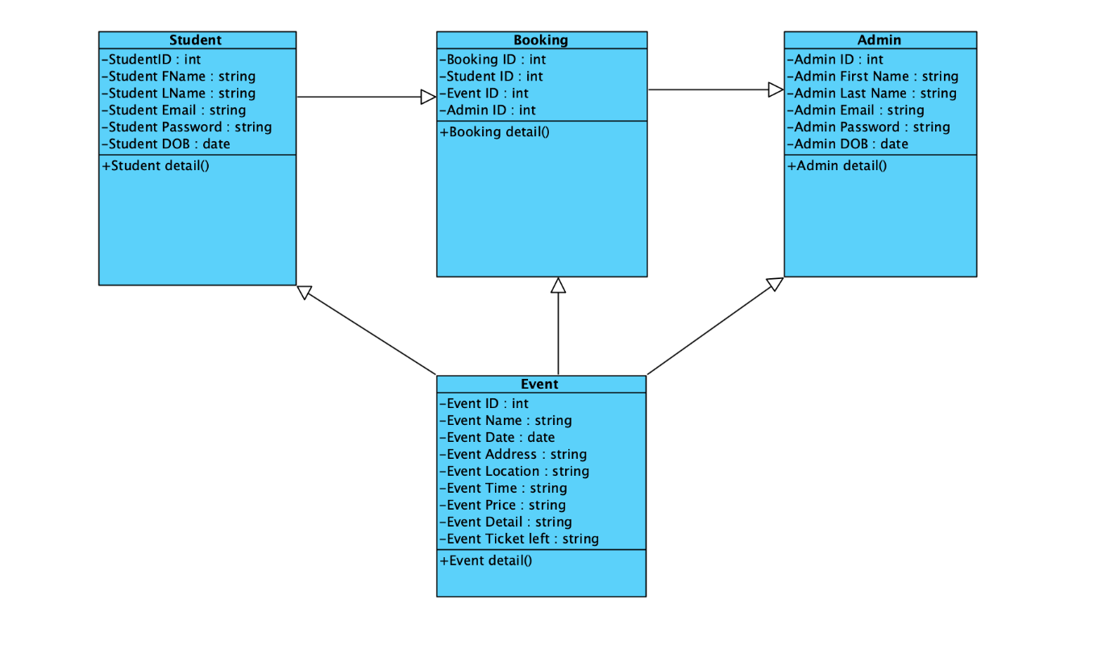

# Entity relationship diagram

The entity relationship between student, booking, admin and event are following:

# Skeleton Tables

Student(StudentID*, Student_FName, Student_LName, Student_Email, Student_Password, Student_DOB)

Booking(Booking_ID*, Student_ID, Event-ID, Admin_ID)

Admin(Admin_ID*, Admin_FName, Admin_LName, Admin_Email, Admin_Password, Admin_DOB)

Event(Event_ID*, Event_Name, Event_Date, Event_Address, Event_Location, Event_Time, Event_Price, Event_Detail, Event_Ticket left)

# Entity Relationships

The entity relation between student, booking, admin and event are following:

Admin

Booking

Student

Event

# In Entity relationship diagrams there are relations between student, booking, admin and event.

1. One to one relationship
2. One to many relationship
3. Many to One relationship
4. Many to many relationship

# Normalisation

The Normalisation table are following:

|  |  |  |  |
| --- | --- | --- | --- |
| UNF | 1NF | 2NF | 3NF |
| **STD_ID**  STD_FName  STD_Surname  STD_DoB  STD_Email  STD_Password  STD_Type  Event_ID  Event_Name  Event_Date  Event_Time  Event_Location  Event_Price  Event_Category  Event_Information  Tickets_left  Booking_ID  Booking Date  Admin_ID  Admin_FName  Admin_Surname  Admin_DoB  Admin_Email  Admin_Password | **STD_ID**  STD_FName  STD_Surname  STD_DoB  STD_Email  STD_Password  STD_Type  **STD_ID**  **Event_ID**  Event_Name  Event_Date  Event_Time  Event_Location  Event_Price  Event_Category  Event_Information  Tickets_left  Booking_ID  Admin_ID  Admin_FName  Admin_Surname  Admin_DoB  Admin_Email  Admin_Password | **STD_ID**  STD_FName  STD_Surname  STD_DoB  STD_Email  STD_Password  STD_Type  **STD_ID**  **Event_ID**  Event_Name  Event_Date  Event_Time  Event_Location  Event_Price  Event_Category  Event_Information  Tickets_left    **STD_ID**  **Booking_ID**  **Admin_ID**  Admin_FName  Admin_Surname  Admin_DoB  Admin_Email  Admin_Password | **STD_ID**  STD_FName  STD_Surname  STD_DoB  STD_Email  STD_Password  STD_Type  **STD_ID**  **Event_ID**  Event_Name  Event_Date  Event_Time  Event_Location  Event_Price  Event_Category  Event_Information  Tickets_Remaining    **STD_ID**  **Booking_ID\***  Event_ID*  **Admin_ID**  Admin_FName  Admin_Surname  Admin_DoB  Admin_Email  Admin_Password |

# Data Dictionary

|  |  |  |  |  |  |  |  |
| --- | --- | --- | --- | --- | --- | --- | --- |
| S | T | U | D | E | N | T |  |
| Field Name | Datatype | Length | Index | Null | Default | Validation rule | Description |
| ID | Number(10) | 11 | PK | No |  |  | ID of student |
| FName | Varchar(10) | 11 |  | No |  |  | FName of student |
| LName | Varchar(20) | 21 |  | No |  |  | LName of student |
| Email | Varchar(30) | 31 |  | No |  | Must be sign @ | Email of student |
| Password | Varchar(40) | 41 |  | No |  |  | Password of student |
| DOB | Date(10) | 11 |  | No |  | Must be format DD/MM/YYYY | DOB of student |

|  |  |  |  |  |  |  |  |
| --- | --- | --- | --- | --- | --- | --- | --- |
| B | O | O | K | I | N | G |  |
| Field Name | Datatype | Length | Index | Null | Default | Validation rule | Description |
| BookingID | Number(10) | 9 | PK | No |  |  | ID of booking |
| StudentID | Number(20) | 19 | PK | No |  |  | ID of student |
| Event ID | Number(30) | 29 | PK | No |  |  | ID of Event |
| AdminID | Number(40) | 39 | Pk | No |  |  | ID of Admin |
|  |  |  |  |  |  |  |  |
|  |  |  |  |  |  |  |  |

|  |  |  |  |  |  |  |  |
| --- | --- | --- | --- | --- | --- | --- | --- |
| A | D | M | I | N |  |  |  |
| Field Name | Datatype | Length | Index | Null | Default | Validation rule | Description |
| ID | Number(10) | 12 | Pk | No |  |  | ID of Admin |
| First Name | Varchar(10) | 22 |  | No |  |  | First Name of Admin |
| Last Name | Varchar(20) | 32 |  | No |  |  | Last Name of Admin |
| Email | Varchar(30) | 42 |  | No |  | Must be @ sign | Email of Admin |
| Password | Varchar(40) | 52 |  | No |  |  | Password of Admin |
| DOB | Date(10) | 12 |  | No |  | Must be format DD/MM/YYYY | DOB of Admin |

|  |  |  |  |  |  |  |  |
| --- | --- | --- | --- | --- | --- | --- | --- |
| E | V | E | N | T |  |  |  |
| Field Name | Datatype | Length | Index | Null | Default | Validation Rule | Description |
| ID | Number(10) | 13 | PK | No |  |  | ID of Event |
| Name | Varchar(10) | 23 |  | No |  |  | Name of Event |
| Date | Date(10) | 33 |  | No |  |  | Date of Event |
| Address | Varchar(20) | 43 |  | No |  |  | Address of Event |
| Location | Varchar(30) | 53 |  | No |  | Must be postcode | Location of Event |
| Time | Varchar(40) | 63 |  | No |  |  | Time of Event |
| Price | Varchar(50) | 73 |  | No |  |  | Price of Event |
| Detail | Varchar(60) | 83 |  | No |  |  | Detail of Event |
| Ticket left | Varchar(70) | 93 |  | No |  |  | Ticket left of Event |

# Database Design

## Tables

Below are the tables that will be in the database. It has been normalised up to 3NF and only stores information that is necessary to save storage.

Campus_events

|  |  |  |  |  |
| --- | --- | --- | --- | --- |
| Field name | Data type | Field size | Data Format | Key |
| Id | NUMBER | Dynamic |  | PRIMARY KEY |
| Name | VARCHAR2 | 200 |  |  |
| Start_timestamp | TIMESTAMP |  | DD:MM:YYYY:HH24:MI:SS |  |
| End_timestamp | TIMESTAMP |  | DD:MM:YYYY:HH24:MI:SS |  |
| Location | VARCHAR2 | 1000 |  |  |
| Details | VARCHAR2 | 4000 |  |  |

Local_events

|  |  |  |  |  |
| --- | --- | --- | --- | --- |
| Field name | Data type | Field size | Data Format | Key |
| Id | NUMBER | Dynamic |  | PRIMARY KEY |
| Name | VARCHAR2 | 200 |  |  |
| Start_timestamp | TIMESTAMP |  | DD:MM:YYYY:HH24:MI:SS |  |
| End_timestamp | TIMESTAMP |  | DD:MM:YYYY:HH24:MI:SS |  |
| Location | VARCHAR2 | 1000 |  |  |
| Details | VARCHAR2 | 4000 |  |  |

Local_support

|  |  |  |  |  |
| --- | --- | --- | --- | --- |
| Field name | Data type | Field size | Data Format | Key |
| Name | VARCHAR2 | 200 |  | PRIMARY KEY |
| Location | VARCHAR2 | 1000 |  |  |
| Details | VARCHAR2 | 4000 |  |  |

Local_poi

|  |  |  |  |  |
| --- | --- | --- | --- | --- |
| Field name | Data type | Field size | Data Format | Key |
| Name | VARCHAR2 | 200 |  | PRIMARY KEY |
| Location | VARCHAR2 | 1000 |  |  |
| Details | VARCHAR2 | 4000 |  |  |

All the tables above have a corresponding bookmark table that is used to link users with the data that they have bookmarked.

Bookmarked_campus_events

|  |  |  |  |  |
| --- | --- | --- | --- | --- |
| Field name | Data type | Field size | Data Format | Key |
| Username | NUMBER | Dynamic |  | PRIMARY KEY |
| Campus_event_id | NUMBER | Dynamic |  | FOREIGN KEY |

Bookmarked_local_events

|  |  |  |  |  |
| --- | --- | --- | --- | --- |
| Field name | Data type | Field size | Data Format | Key |
| Username | NUMBER | Dynamic |  | PRIMARY KEY |
| Local_event_id | NUMBER | Dynamic |  | FOREIGN KEY |

Bookmarked_local_support

|  |  |  |  |  |
| --- | --- | --- | --- | --- |
| Field name | Data type | Field size | Data Format | Key |
| Username | NUMBER | Dynamic |  | PRIMARY KEY |
| Local_support_name | VARCHAR2 | 200 |  | FOREIGN KEY |

Bookmarked_local_poi

|  |  |  |  |  |
| --- | --- | --- | --- | --- |
| Field name | Data type | Field size | Data Format | Key |
| Username | NUMBER | Dynamic |  | PRIMARY KEY |
| Local_poi_name | VARCHAR2 | 200 |  | FOREIGN KEY |

## SQL

Below is the SQL code used in order to make the tables shown above.

|  |  |
| --- | --- |
| -- Make campus events table  CREATE TABLE campus_events(  id NUMBER NOT NULL CONSTRAINT campus_events_id_pk PRIMARY KEY,  name VARCHAR2(200) NOT NULL,  start_timestamp TIMESTAMP NOT NULL,  end_timestamp TIMESTAMP NOT NULL,  location VARCHAR2(1000) NOT NULL,  details VARCHAR2(4000) NOT NULL  );  -- Make sequence for trigger later  CREATE SEQUENCE campus_events_id_sequence;  -- Trigger to do incerement  CREATE OR REPLACE TRIGGER campus_events_on_insert  BEFORE INSERT ON campus_events  FOR EACH ROW  BEGIN  SELECT campus_events_id_sequence.nextval  INTO :new.id  FROM dual;  END;  -- Make bookmarked campus event table  CREATE TABLE bookmarked_campus_events(  username NUMBER NOT NULL CONSTRAINT student_id_bookmark_campus_events_pk PRIMARY KEY,  campus_event_id NUMBER,  CONSTRAINT campus_event_id_fk FOREIGN KEY (campus_event_id) REFERENCES campus_events(id)  ); | -- Make local events table  CREATE TABLE local_events(  id NUMBER NOT NULL CONSTRAINT local_events_id_pk PRIMARY KEY,  name VARCHAR2(200) NOT NULL,  start_timestamp TIMESTAMP NOT NULL,  end_timestamp TIMESTAMP NOT NULL,  location VARCHAR2(1000) NOT NULL,  details VARCHAR2(4000) NOT NULL  );  -- Make sequence for trigger later  CREATE SEQUENCE local_events_id_sequence;  -- Trigger to do incerement  CREATE OR REPLACE TRIGGER local_events_on_insert  BEFORE INSERT ON local_events  FOR EACH ROW  BEGIN  SELECT local_events_id_sequence.nextval  INTO :new.id  FROM dual;  END;  -- Make bookmarked local event table  CREATE TABLE bookmarked_local_events(  username NUMBER NOT NULL CONSTRAINT student_id_bookmark_local_events_pk PRIMARY KEY,  local_event_id NUMBER,  CONSTRAINT local_event_id_fk FOREIGN KEY (local_event_id) REFERENCES local_events(id)  ); |
| -- Make local support table  CREATE TABLE local_support(  name VARCHAR2(200) NOT NULL CONSTRAINT support_pk PRIMARY KEY,  location VARCHAR2(1000) NOT NULL,  details VARCHAR2(4000) NOT NULL  );  -- Make bookmarked support table  CREATE TABLE bookmarked_support(  username NUMBER NOT NULL CONSTRAINT student_id_bookmark_support_pk PRIMARY KEY,  local_support_name VARCHAR2(200),  CONSTRAINT support_name_fk FOREIGN KEY (local_support_name) REFERENCES local_support(name)  ); | -- Make points of interest table  CREATE TABLE local_poi(  name VARCHAR2(200) NOT NULL CONSTRAINT local_poi_id_pk PRIMARY KEY,  location VARCHAR2(1000) NOT NULL,  details VARCHAR2(4000) NOT NULL  );  -- Make bookmarked point of interest table  CREATE TABLE bookmarked_poi(  username NUMBER NOT NULL CONSTRAINT student_id_bookmark_poi_pk PRIMARY KEY,  local_poi_name VARCHAR2(200),  CONSTRAINT poi_name_fk FOREIGN KEY (local_poi_name) REFERENCES local_poi(name)  ); |

# User-interface design

The client has said that the system should be easy to use. In order to do this the design should be a simple and as straight forward as possible. The client should also work on multiple platforms and devices, so the front-end design should be designed around multiple devices instead of just one.

Home Page

The home page is designed to be as simple as possible. In the top left is a navigation menu button that will open the navigation menu on the left with buttons to all the different pages. The buttons to the pages are also on the main page, three wide and how ever many down, depending on the need. Having the buttons like this mean that no matter the size of the page they will be easy to see and use.

All other pages will link back to the homepage and the navigation bar will be accessible everywhere, so people should not get lost within the app.

The other pages will mainly be a list of buttons that when clicked will display more information and have a button to bookmark for later.

# Security

The software has multiple types of users, all with different levels of security. Doing this means that only certain people will be able to access certain things, making the app secure. These user levels have been described earlier, so I will not go over them again, but the main thing is these levels can be added to and taken away depending on the progression of the software.

# Implementation of kiosk

Due to the time constraints and the issues within the group we have been unable to make a working example of the kiosk. If given more time and maybe more people, the work we have done could be made into a working software.

# Test system

We are not able to test the system because it does not exist but if we were to test it we would use a variety of tests, including test cases and having other people test the software and fill out a questionnaire of their experience.

The test cases would be used in order to make sure that there are no major issues with the software, it will also test for common minor issues that may happen.

Once the test cases are done the test users will include university students, university lecturers and the university event management team.

# Future evolutions

After the tests were completed, we would then look into the future of the software. The software would evolve depending on what the stakeholders desire. This would be determined by having the users fill out questionnaires/give their opinions on how the software is already running and what they think can be added to improve it.

# Conclusion

In conclusion, the student information kiosk project was done with different ideas. Our group started with six people but ended with two (Zaid and Michael) because of a variety of things including: people not responding to messages, peoples schedule and issues caused by the coronavirus. These issues caused a lot of time to be wasted, making the project very difficult to complete to the desired standard. We did what we could given the constrains and are happy with the work we have done but wished we had more time/a better group so we could get more done.

# Appendix